

Year 7
Maths Booklet

Name:
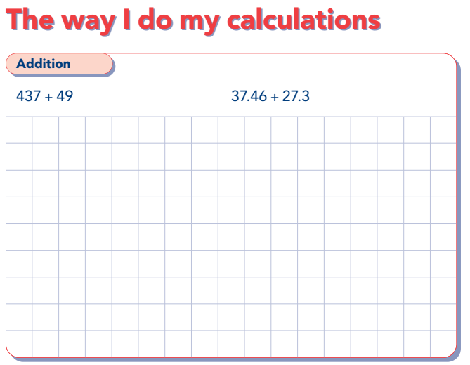
Calculations

A 2 + 6 | B 12 + 24 | C 91 + 81 | D 74 + 28
E 98 + 55 | F + 33 = 97 | G 179 + 361 | H 894 + 317
I 520 + =844 | J 3.1 + 5.2 | K 3.5 + = 4.8 | L 12.45 + 7.46
M 35 + 45.67 | N 5.1 + 7.12 + 15.8 | O 26.74 + 58.3 | P 63.8 + 23.71 + 5

Worded Problems
- If the Eifel tower is 298m tall and the London Shard is 309m. What is their combined height?

- James has £467 in the bank, he pays what is left of his birthday money to it. If he pays in his £45.57, how much does he have in total?

- Ryan goes shopping. In the first shop he spends £66.73, in the second £25, the third £156 and £14.56 in the last shop. How much money does he spend total?

Spot the mistake.
+ 238  1487  3867 | + 238  526  754
+ 5  2.3  2.8 | + 438  21.6  65.4
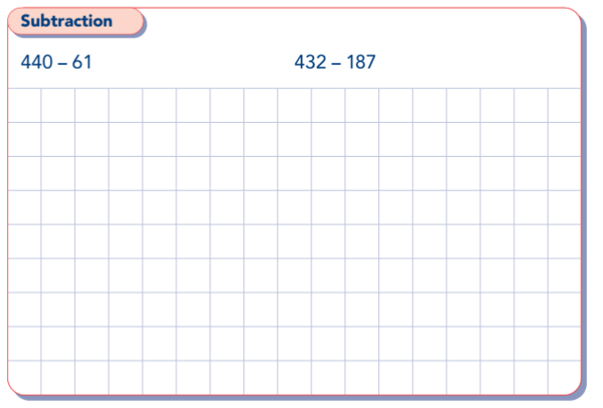
Calculations

A 8 - 3 | B 36 - 24 | C 47 - 18 | D 74 - 56
E 100 - 58 | F - 33 = 45 | G 798 - 268 | H 1012 - 389
I 844 - = 541 | J 8.7 - 6.5 | K 3.5 - = 1.2 | L - 3.6 = 9.7
M 74.63 – 17.21 | N 6 – 2.4 | O 78.54 – 13.6 | P 586 – 85.31

Worded Problems
- The London Eye is 117m tall and BT tower is 190m tall. How much taller is the BT tower than the London Eye?

- If the distance from Cardiff to London is 172miles and Amy has driven 87 miles. How many miles has Amy got left before she reaches London?

- Alex is checking the addition of 2 numbers. The ANSWER is 843, one of the numbers is 591, what is the other number in the sum?

Spot the mistake.
6783-  47  2383 | 567 –  138  431
83.69 –  782.7  54.2 | 8532-  23.1  830.1
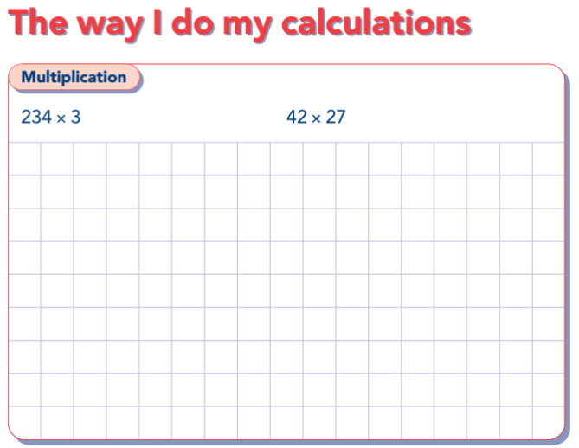
Calculations
A 8 x 7 | B 12 x 10 | C 11 x 12 | D 134 x 2
E x 4 = 56 | F 361 x 5 | G 426 x 4 | H 243 x = 486
I 672 x 7 | J 2456 x 5 | K 24 x 12 | L 68 x 47
M 384 x 67 | N 34.5 x 3 | O 57.24 x 3 | P 465.78 x 8
Worded Problems
- How many days in 17 weeks?

- If eggs are packed in boxes of 6. How many eggs altogether in 248 boxes?

- Dylan gets paid £5.75 every evening to do a paper round. How much does he earn if he competes the round every evening in May?

Spot the mistake.
45x  3  1215 | 85.35 x  6  51210
38.4x  6  23.04 | 352x  4  1409

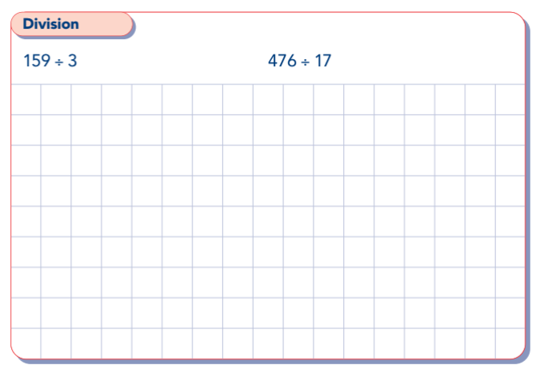
Calculations
A 8 ÷ 2 | B 35 ÷ = 5 | C 36 ÷ 9 | D ÷ 7 = 8
E 72 ÷ 3 | F ÷ 8 = 13 | G 130 ÷ 10 | H 168 ÷ 7
I 52 ÷ = 4 | J 258 ÷ 8 | K 121 ÷ = 11 | L 1655 ÷ 5
M 2392 ÷4 | N 12.45 ÷ 5 | O 145.18 ÷ 2 | P 6205.35 ÷ 3
Worded Problems
- James, Simon and Angela win £771 between them in a draw. How much money do they each get?

- 3600 football supporters want to go to an away game together. A coach holds 50 passengers. How many coaches would they need to all go to the game?

- Fin buys sherbet straws from the newsagents. They cost 4p each and he spends £1.12. How many straws has he bought?

Spot the mistake.
201  3 623 | 1095  5 547.5
31  3 903 | 14  9 135

